Income Inequality in the US
Economics, History, and Social Impact

A panel discussion with

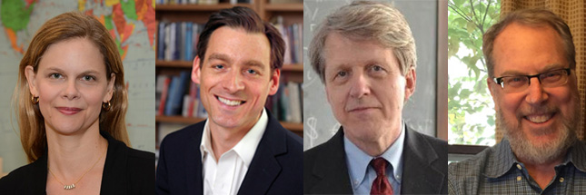

Beverly Gage – History
Brady-Johnson Program in Grand Strategy
Jacob Hacker – Political Science
Center for the Study of Inequality
Robert Shiller – Economics
Cowles Foundation for Research in Economics

Moderator: Matt Jacobson – American Studies, History

5 pm Thursday, February 22

Whitney Humanities Center Auditorium

In conjunction with the gallery exhibit "Trapped in the Middle: Photographs by Julian Fisher"
Departments of American Studies, Economics, History, and Political Science; Institution for Social and Policy Studies; and Whitney Humanities Center

